Project

# Case Description

## Context

GATOR RENEWABLE ENERGIES Inc. or simply GatoRE is a Florida-based renewable energy corporation that undertakes the implementation and operation of projects in the energy sector, such as:

* Public policy and utilities consulting services
* The appraisal and engineering design of renewable energy plants of any size including domestic ones
* The assembly of energy production and transmission compact units (PV panels, inverters, AC substations, wind-turbines, generators, etc.)
* The development and installation of renewable energy plants
* The operation and maintenance of energy plants
* The delivery, installation and replacement of equipment and spare parts for power plants and distribution
* The evaluation and financing of renewable energy projects from large scale utility plants to domestic ones

The company’s HQ are in Gainesville, FL.

## Specifics

You are the Director of Quality Control for the GatoRE Equipment & Material (E&M) Business Unit.

GatoRE E&M is a trading unit that procures equipment and material to the other business units of the corporation as well as outside customers.

Some of the items it trades are assemblies of the corporation’s GatoRE Technicians (Techs) assembly line.

In order to maintain a high quality of service, it has well established quality procedures and testing labs that run on sound quality control practices.

The Unit has a well-organized parcel delivery system for its merchandise, which operates with its own fleet of trucks.

Figure 1: Business process of the Business Unit

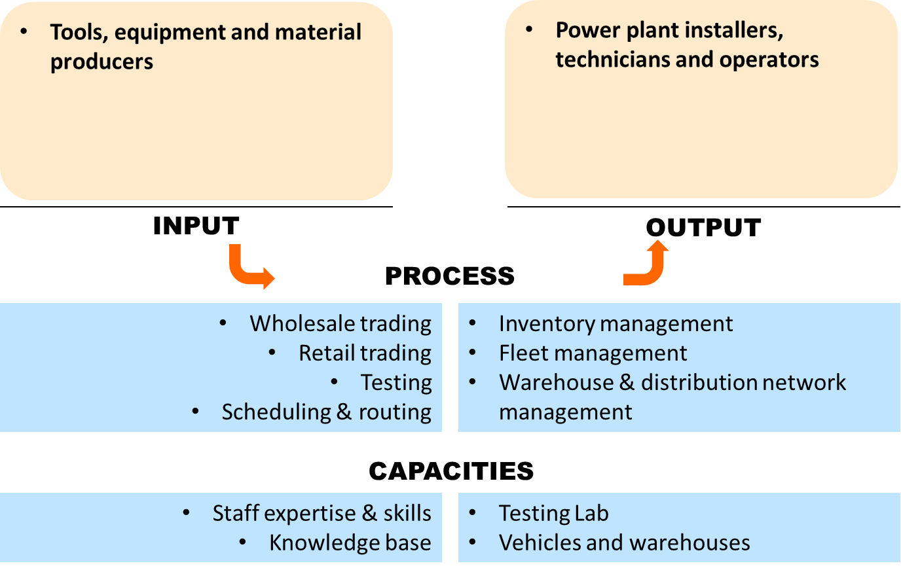

Figure 2: Organization of the Business Unit

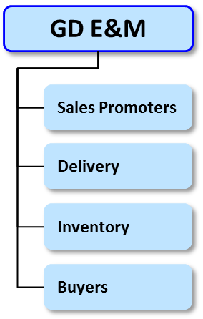

## Data

All data are found in the project.xlsx file.

# Tasks

## Part 1

GatoRE is going to purchase fuses, which are one of the most important components in assembly of energy production units. They are considering four different suppliers and want to choose the best one in terms of fuse life span. You are responsible to select the best supplier. Data regarding the life of fuses for all brands have been collected and provided in Table 1.1 in excel.

Do a comprehensive quantitative statistical analysis using any applicable below tools to select the best supplier. You need to prove and support all your reasoning and explanation statistically.

* Histograms
* Stem and leaf plot
* Box plot
* Probability plots
* Hypothesis testing
* Regression model
* Shewhart cycle
* Pareto analysis
* Cause and effect diagrams

## Part 2

GatoRE placed an order of 18,000 fuses from the selected supplier and supplier sent the order in two lots of size 9,000. In order to inspect the sampled fuses, the inspector grabs it firmly with a pair of needle nose pliers and hold it up to light and check the metal wire for signs of damage or break. If they see any sign of damage, the inspected fuse is considered as a defective item.

Historically, the average incoming quality is 1% with $P_{a}$ = 94% and the desired outgoing quality is 0.93%. Inspecting each unit costs $15 and they have a budget of $1500 for inspections.

1. Design a single sampling plan
2. Design a double sampling plan, which provides the same protection as the single sampling plan. Which one would you choose? Why?

## Part 3

GatoRE is manufacturing and assembling energy units and trying to evaluate the manufacturing process capability and quality. Assume that you are hired as a GatoRE quality engineer to inspect the energy unit manufacturing process. Two quality characteristics of fuse including ambient temperature and breaking capacity, which have a significant impact on the overall quality of energy units, have been measured and the measurement data are provided in table 3.1 and Table 3.2 in excel.

1. How would you evaluate the process quality and capability in terms of two quality characteristics? Specifically focus on control process and if processes are not in control make suggestions on how to bring them under control? Justify your answer qualitatively and quantitatively.
2. GatoRE has purchased a new instrument to measure the breaking capacity of fuses. Thirty units of the product are obtained and two process operators measure each unit of product 3 times. The data are provided in Table 3.3 in excel. As a part of the quality improvement team in designing the SPC system how would you do Gauge R&R analysis and assess the measurement system capability after having done the measurement capability analysis.

## Part 4

One of the energy production units which is installed by the company is wind turbine. Their installed wind turbines are supposed to deliver stable energy output to the client. There are three factors affecting the stability of delivered energy including

* Number of blades,
* Tower height
* Generator efficiency.

An experiment was performed and repeated 3 times to measure the value of energy stability. Table 4.1 presents the observed data for this experiment.

1. Analyze and interpret the effect of factors on energy stability. Justify your answer qualitatively and quantitatively.
2. If you are responsible to purchase the three components, you need to consider performance and economic aspects. From performance perspective you might be willing to buy 80-meter tower, higher (95%) efficiency generator and 3 blades. However, from economic perspective you might be interested in buying 2blades and lower tower and lower efficient generator.

You have a and limited budget of 3525000$ and need to purchase the required components for 5 wind turbine. Which components will you purchase? Why? Explain your answer qualitatively and quantitatively. (negative stability means zero or very non-satisfactory stability)

If for your analysis need the specification levels and level of significance, use the values from the below table.

|  |  |
| --- | --- |
| α | 0.05 |
| USL | 170 |
| LSL | 120 |

# Deliverables

Each group is supposed to submit one report in a single PDF file. Your report should have a cover page including the course name, course number, section, group members names. The solutions for each part including calculations, plots, figures and explanations should be determined clearly. The R codes that you have written for your solutions, should be copied in the appendix and referred to by part number and question letter.